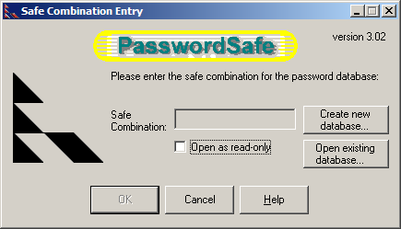
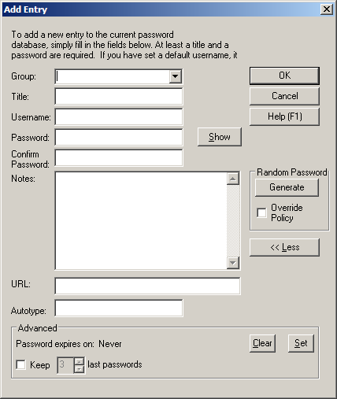

Summary
This program looks like it'd be great for people who don't remember passwords very well. For me, all of my passwords are permutations on the same five or six long passwords, so I don't have much trouble remembering them. I also don't think that putting all of my passwords in a single database is a very safe idea. But for a person who has a lot of passwords to remember, it would be great I guess.

